**Lab on Disk Manual**

Accessories

* BLED112 USB Dongle ([https://www.eibtron.com/epages/eibtron.sf/en_GB/?ObjectPath=/Shops/eibtron/Products/807-7742](https://www.google.com/url?q=https%3A%2F%2Fwww.eibtron.com%2Fepages%2Feibtron.sf%2Fen_GB%2F%3FObjectPath%3D%2FShops%2Feibtron%2FProducts%2F807-7742&sa=D&sntz=1&usg=AFQjCNGMhkDVyZ41ptd0I4mzjn0UZKwb7A))

Software

Labview 2013 or above

Drivers

* NI-VISA
* NI-488.2
* BLE Toolkit

**Instructions: Getting the Mac Address and installing BLE toolkit**

https://forums.ni.com/t5/Community-Documents/LabVIEW-BLE-Bluetooth-Low-Energy-toolkit/tac-p/3595025#M3652

1. Get a BLED112 USB dongle (e.g. in [Digi-Key](http://www.digikey.com/catalog/en/partgroup/bled112-bluetooth-smart-dongle/40600))
2. Install the [drivers provided by Bluegiga (normally the dongle installs them by its own)](https://www.bluegiga.com/en-US/download/?file=b2lWNsg0R1SG8qXOhOO1LA&title=BLED112%2520Windows%2520Driver&filename=BLED112_Signed_Win_Drv.zip)3. Verify the COM number for the dongle in Device Manager > Ports
3. Download and install the LabVIEW BLE Toolkit
4. Open the **ble_scan_devices.vi** example provided in  
   <Labview>\examples\BLE\Examples\ble_scan_devices.vi
5. Select the COM port for your BLED112 dongle
6. Run the VI

**Instruction: Controlling with disk view**

1. Select “Disk View” in the mode control switch

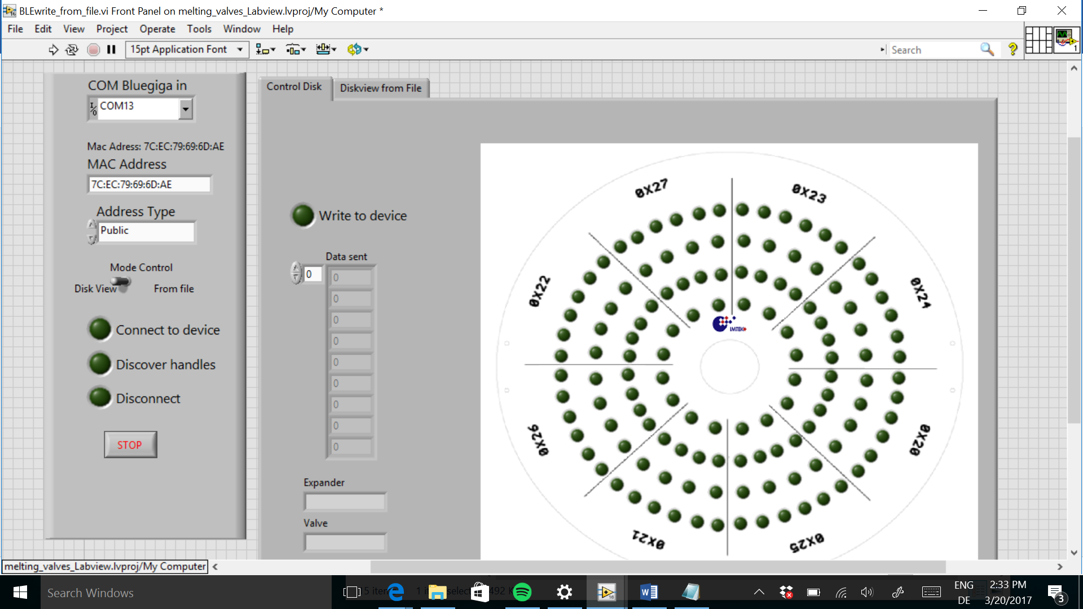

1. Select “Control disk” Tab
2. Select the Com of the USB Dongle
3. Put the MAC Address of the device (The MAC address (7C:EC:79:69:6D:AE) was used for testing with the prototype in lab. The address obtained from scan devices should be used)
4. Select the Address Type (obtained from Scan devices. Normally: Public)
5. Run the VI
6. The Leds of state (Connect to device, Discover Handles and Write to device) should turn on
   1. If they didn´t turn on, disconnect the dongle and reset the arduino. This mistake occurs when the communication is not closed correctly (Abort Execution is used instead of the Stop in the program).
7. Control the Valves by turning ON and OFF the leds in the disk.
8. Click Stop to end the communication (don’t use abort execution)

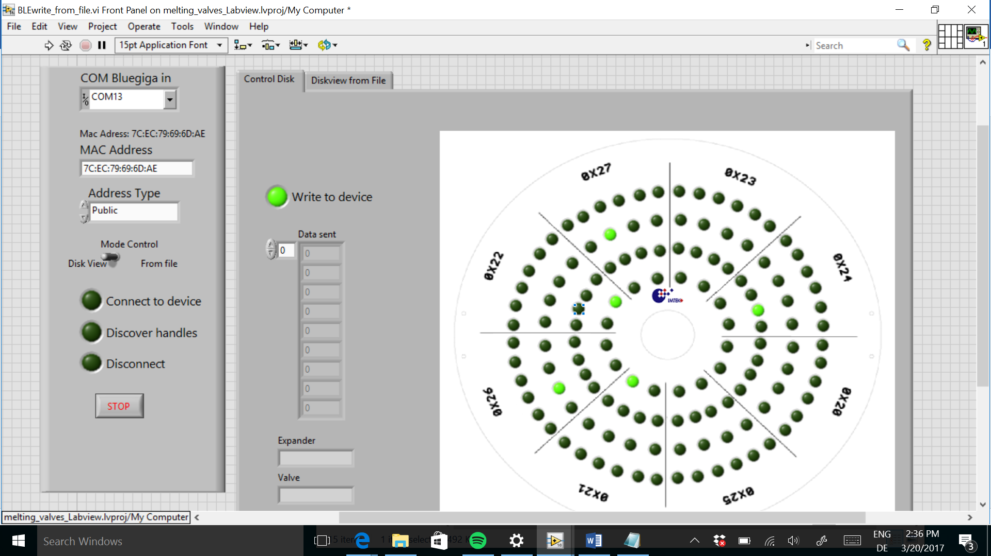

**Instruction: Controlling Disk from File**

1. Select “From File” in the mode control switch
2. Select Tab “Disk from file”
3. Select File that want to be read.
   1. Should be a .txt file.
   2. The format is the next: 20,8000. The first 2 numbers correspond to the expander. The last numbers correspond to the state of the valves.
   3. If time wants to be set between the instructions, the time should be entered with a t at the beginning: t,2000. This will create a waiting time of 2 seconds.

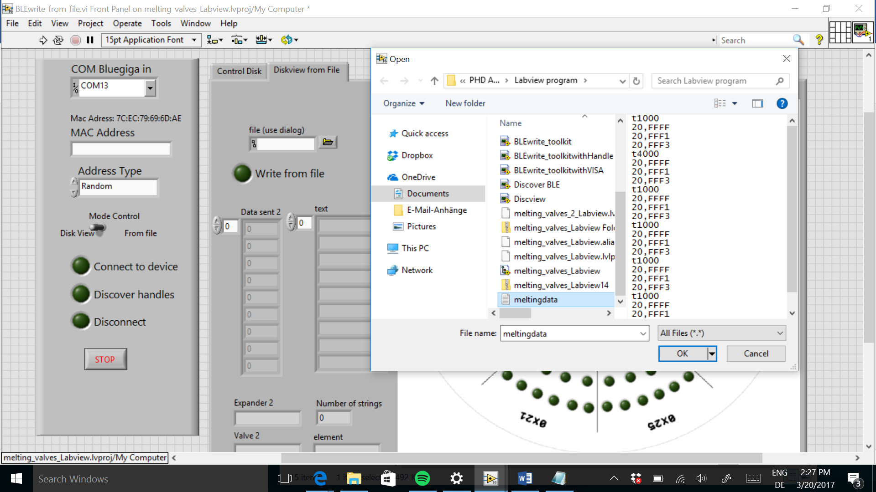



1. Select the Com of the USB Dongle
2. Put the MAC Address of the device (The MAC address (7C:EC:79:69:6D:AE) was used for testing with the prototype in lab. The address obtained from scan devices should be used.)
3. Select the Address Type (obtained from Scan devices. Normally: Public)
4. Run the VI
5. Click Stop to end communication or the program will end once the instructions are over.

Example Instruction:

t1000 // waits 1 second

20,FFFF

23,FFF1

25,FFF3// the three instructions are executed at the same time

t4000 // waits 4 seconds

21,FFFF

27,FFF1

22,FFF3

// end of program